Selection sort in c++
#include <iostream>
using namespace std;

int main() {
int n;

cout << "Enter number of elements: ";
cin >> n;

int arr[n];

cout << "Enter elements:\n";
for(int i = 0; i < n; i++) {
cin >> arr[i];
}

// Selection Sort
for(int i = 0; i < n - 1; i++) {
int minIndex = i;

for(int j = i + 1; j < n; j++) {
if(arr[j] < arr[minIndex]) {
minIndex = j;
}
}

// Swap
int temp = arr[i];
arr[i] = arr[minIndex];
arr[minIndex] = temp;
}

cout << "Sorted array:\n";
for(int i = 0; i < n; i++) {
cout << arr[i] << " ";
}

return 0;
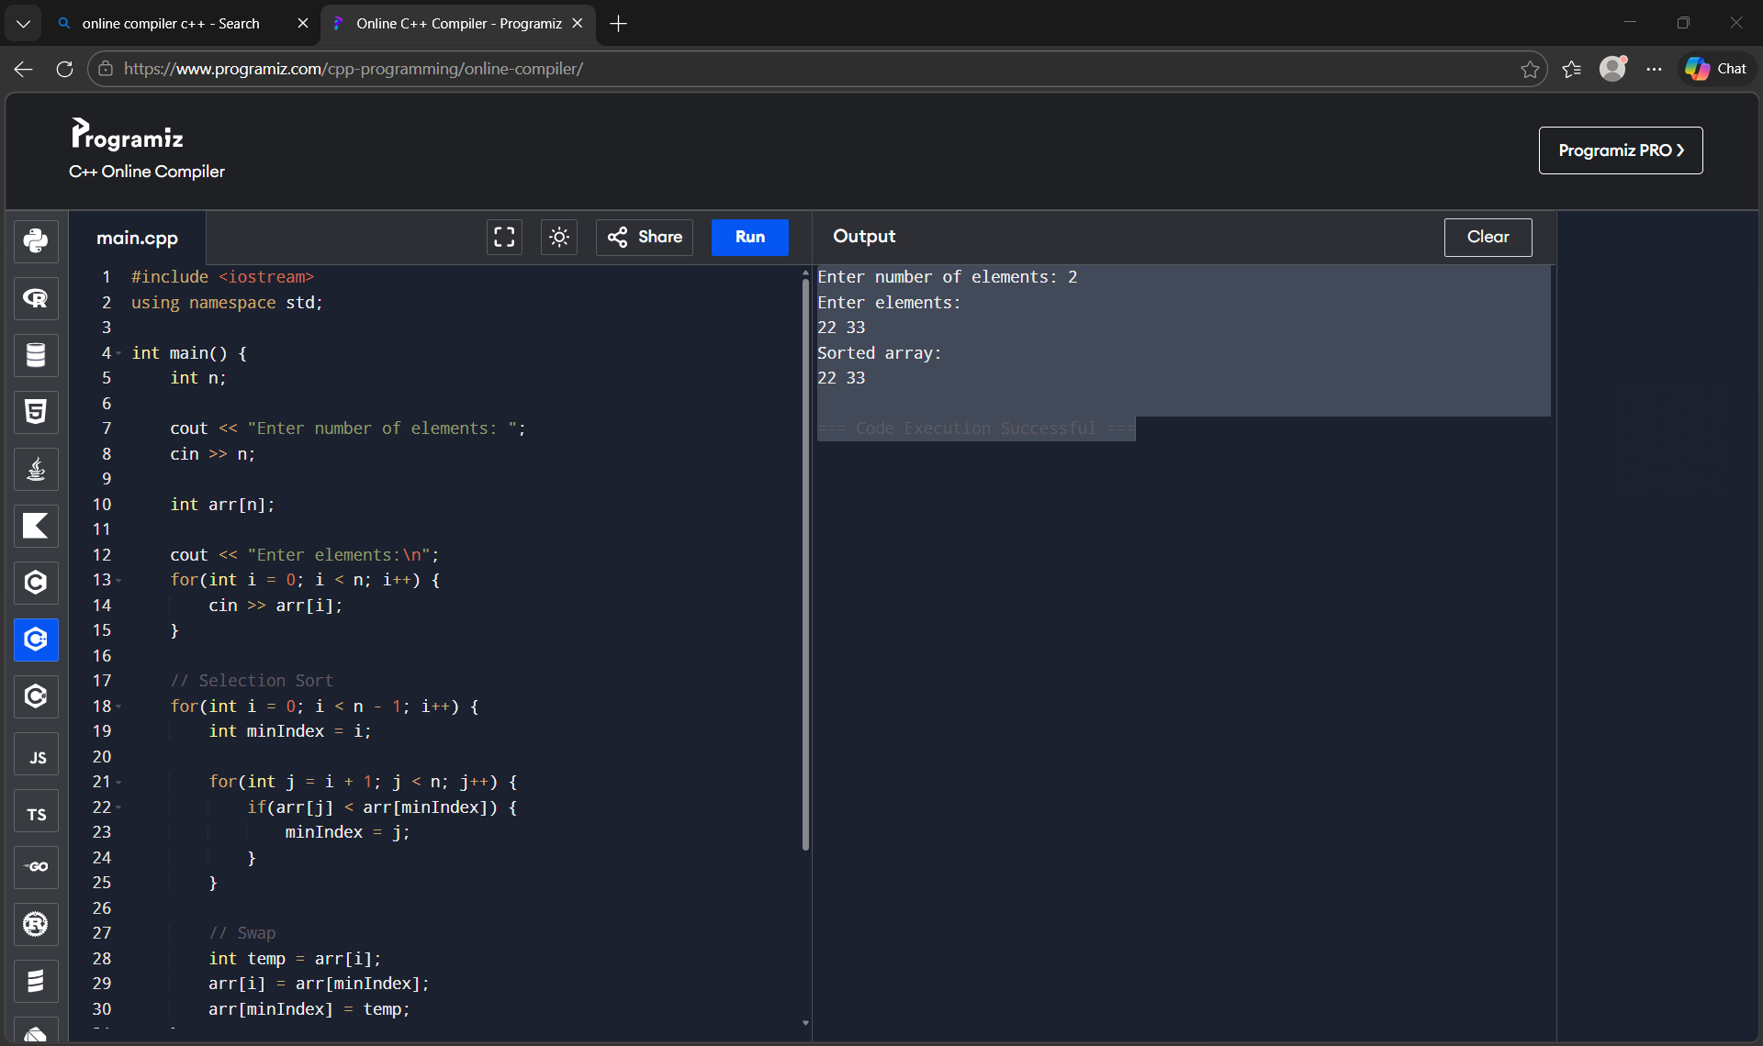

Insertion sort in c++
#include <iostream>
using namespace std;
int main() {
int n;
cout << "Enter number of elements: ";
cin >> n;
int arr[n];
cout << "Enter elements:\n";
for(int i = 0; i < n; i++) {
cin >> arr[i];
}
// Insertion Sort
for(int i = 1; i < n; i++) {
int key = arr[i];
int j = i - 1;
// Shift elements greater than key
while(j >= 0 && arr[j] > key) {
arr[j + 1] = arr[j];
j--;
}
arr[j + 1] = key;
}
cout << "Sorted array:\n";
for(int i = 0; i < n; i++) {
cout << arr[i] << " ";
}
return 0;
}
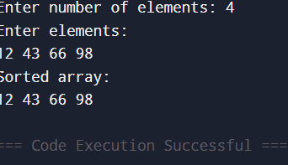

Binary serach in c++
#include <iostream>
using namespace std;

int main() {
int n, key;

cout << "Enter number of elements: ";
cin >> n;

int arr[n];

cout << "Enter sorted elements:\n";
for(int i = 0; i < n; i++) {
cin >> arr[i];
}

cout << "Enter element to search: ";
cin >> key;

int low = 0, high = n - 1, mid;
bool found = false;

while(low <= high) {
mid = (low + high) / 2;

if(arr[mid] == key) {
cout << "Element found at position " << mid + 1;
found = true;
break;
}
else if(arr[mid] < key) {
low = mid + 1;
}
else {
high = mid - 1;
}
}

if(!found) {
cout << "Element not found";
}

return 0;
}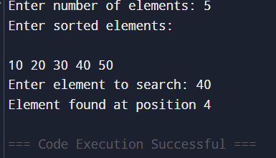

Bubble sort in c++
#include <iostream>
using namespace std;

int main() {
int n;

cout << "Enter number of elements: ";
cin >> n;

int arr[n];

cout << "Enter elements:\n";
for(int i = 0; i < n; i++) {
cin >> arr[i];
}

// Bubble Sort
for(int i = 0; i < n - 1; i++) {
for(int j = 0; j < n - i - 1; j++) {
if(arr[j] > arr[j + 1]) {
// Swap
int temp = arr[j];
arr[j] = arr[j + 1];
arr[j + 1] = temp;
}
}
}

cout << "Sorted array:\n";
for(int i = 0; i < n; i++) {
cout << arr[i] << " ";
}

return 0;
}
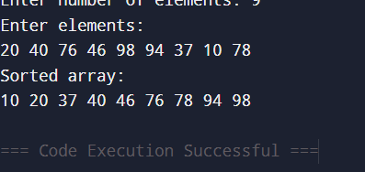

Knapsack in c++
#include <iostream>
using namespace std;

int main() {
int n, W;

cout << "Enter number of items: ";
cin >> n;

int wt[n], val[n];

cout << "Enter weights:\n";
for(int i = 0; i < n; i++) {
cin >> wt[i];
}

cout << "Enter values:\n";
for(int i = 0; i < n; i++) {
cin >> val[i];
}

cout << "Enter capacity of knapsack: ";
cin >> W;

int dp[n+1][W+1];

// Build DP table
for(int i = 0; i <= n; i++) {
for(int w = 0; w <= W; w++) {
if(i == 0 || w == 0)
dp[i][w] = 0;
else if(wt[i-1] <= w)
dp[i][w] = max(val[i-1] + dp[i-1][w - wt[i-1]], dp[i-1][w]);
else
dp[i][w] = dp[i-1][w];
}
}

cout << "Maximum value = " << dp[n][W];

return 0;
}
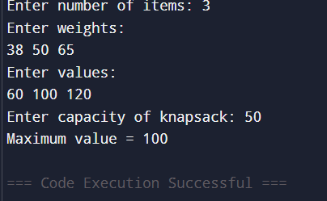

Linear search in c++
#include <iostream>
using namespace std;

int main() {
int n, key;

cout << "Enter number of elements: ";
cin >> n;

int arr[n];

cout << "Enter elements:\n";
for(int i = 0; i < n; i++) {
cin >> arr[i];
}

cout << "Enter element to search: ";
cin >> key;

bool found = false;

for(int i = 0; i < n; i++) {
if(arr[i] == key) {
cout << "Element found at position " << i + 1;
found = true;
break;
}
}

if(!found) {
cout << "Element not found";
}

return 0;
}
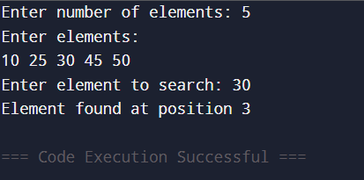

Merge sort in c++
#include <iostream>
using namespace std;

void merge(int arr[], int left, int mid, int right) {
int i = left, j = mid + 1, k = 0;
int temp[100]; // temporary array

while(i <= mid && j <= right) {
if(arr[i] < arr[j])
temp[k++] = arr[i++];
else
temp[k++] = arr[j++];
}

while(i <= mid)
temp[k++] = arr[i++];

while(j <= right)
temp[k++] = arr[j++];

for(int i = left, k = 0; i <= right; i++, k++) {
arr[i] = temp[k];
}
}

void mergeSort(int arr[], int left, int right) {
if(left < right) {
int mid = (left + right) / 2;

mergeSort(arr, left, mid);
mergeSort(arr, mid + 1, right);

merge(arr, left, mid, right);
}
}

int main() {
int n;

cout << "Enter number of elements: ";
cin >> n;

int arr[n];

cout << "Enter elements:\n";
for(int i = 0; i < n; i++) {
cin >> arr[i];
}

mergeSort(arr, 0, n - 1);

cout << "Sorted array:\n";
for(int i = 0; i < n; i++) {
cout << arr[i] << " ";
}

return 0;
}
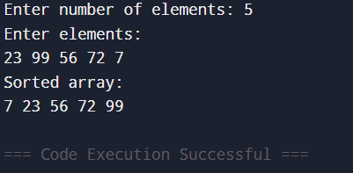

Traveling salesman problem in c++
#include <iostream>
#include <climits>
using namespace std;

int n = 4; // number of cities

int dist[10][10] = {
{0, 10, 15, 20},
{10, 0, 35, 25},
{15, 35, 0, 30},
{20, 25, 30, 0}
};

int dp[1 << 10][10];

// Function to solve TSP
int tsp(int mask, int pos) {
if(mask == (1 << n) - 1) // all cities visited
return dist[pos][0]; // return to start

if(dp[mask][pos] != -1)
return dp[mask][pos];

int ans = INT_MAX;

for(int city = 0; city < n; city++) {
if((mask & (1 << city)) == 0) {
int newAns = dist[pos][city] +
tsp(mask | (1 << city), city);
ans = min(ans, newAns);
}
}

return dp[mask][pos] = ans;
}

int main() {
// Initialize dp array
for(int i = 0; i < (1 << n); i++) {
for(int j = 0; j < n; j++) {
dp[i][j] = -1;
}
}

cout << "Minimum travelling cost = " << tsp(1, 0);

return 0;
}
